# 20210111
# A link to Graylog, where to see information about was email sent or not.
# It was taken from task https://forge.tcsbank.ru/case/4832926/info
# https://ha-graylog.tcsbank.ru/streams/5b2cc69632f0674c83d21d44/search?rangetype=relative&fields=message%2Csource&width=1916&highlightMessage&q=&streams=5b2cc69632f0674c83d21d44&relative=300
#
# Here are all messages sent via Communigate (as I understand).
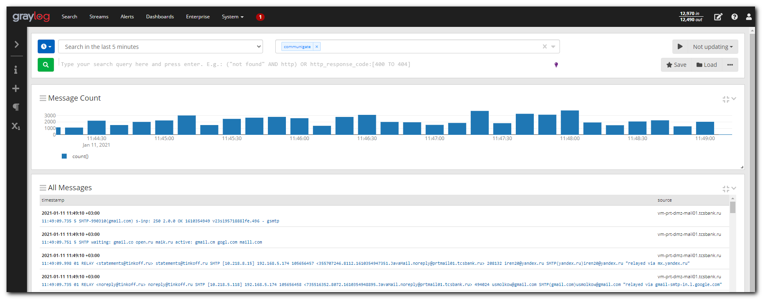
#
# If expand rows, I can find information about Communigate servers, where I try to find information about had not sent email.
# In this case, for example, the server is vm-prt-dmz-mail01.
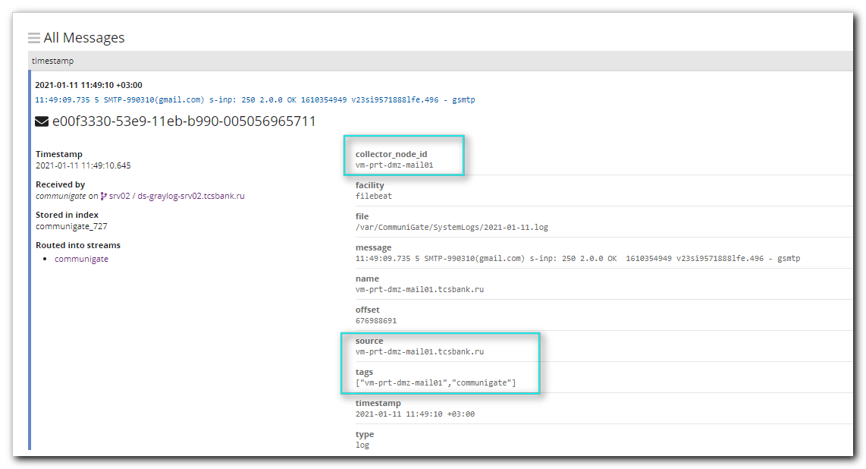
# But somtime it could be m1-mail55.
# And filter looks like this: NOT source:vm\-prt\-dmz\-mail01.tcsbank.ru
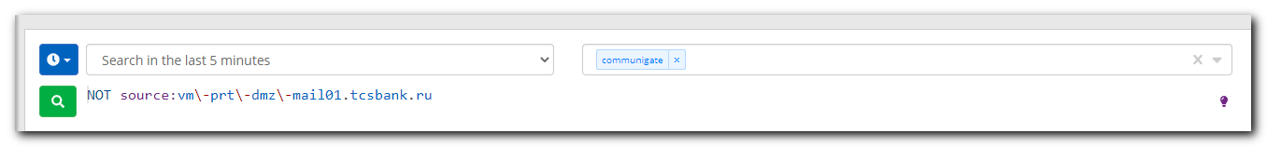
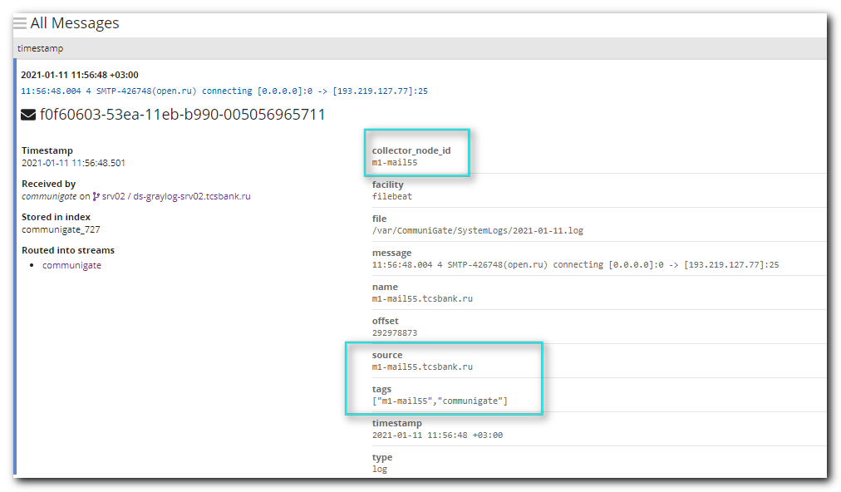
#
# To make the filter easier - expand message and push on black rectangle in the field “source” and then choose from appeared menu “Exclude from results”.
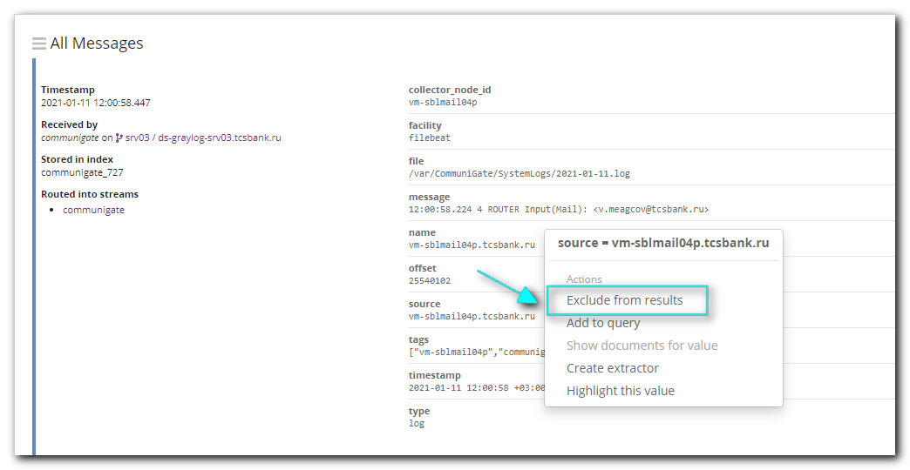

#
# Here is how they tested it. https://ha-graylog.tcsbank.ru/streams/5b2cc69632f0674c83d21d44/search?rangetype=absolute&fields=message%2Csource&width=1916&highlightMessage=&q=%22sadykov_adel_91%40mail.ru%22&streams=5b2cc69632f0674c83d21d44&from=2020-12-28T21%3A00%3A00.000Z&to=2021-01-06T14%3A40%3A23.853Z
#
# These fields contain follow.
2020-12-29 00:00:00.000
2021-01-06 17:40:23.853
"sadykov_adel_91@mail.ru"
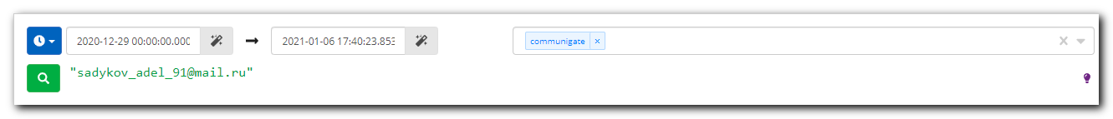
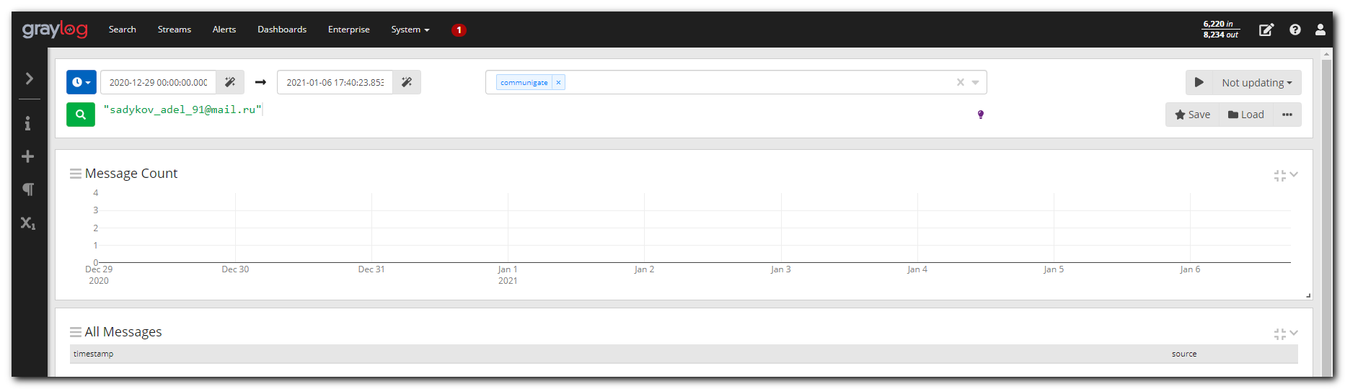

#
# Here are related links.
#
https://wiki.tcsbank.ru/pages/viewpage.action?pageId=15475914

https://wiki.tcsbank.ru/pages/viewpage.action?pageId=577597899

https://forge.tcsbank.ru/case/4769820/info
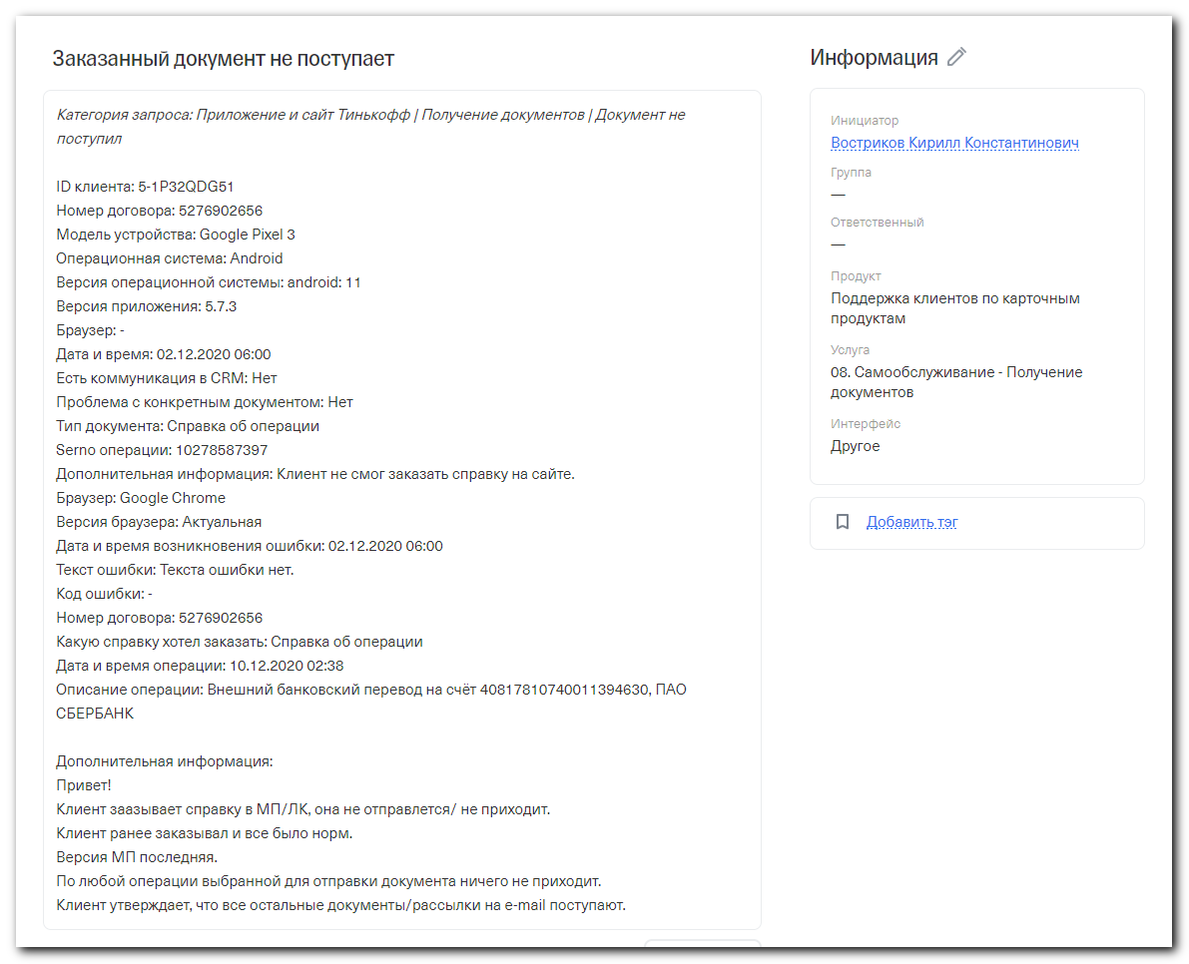

Никитин Филипп Евгеньевич
Коллеги, судя по логам не смогли передать письмо , можем причину проверить? Данные из graylog ниже
Вчера 14:57
Никитин Филипп Евгеньевич
https://ha-graylog.tcsbank.ru/streams/5b2cc69632f0674c83d21d44/search?q=%22t001tt%40yahoo.com%22&rangetype=relative&streams=5b2cc69632f0674c83d21d44&relative=2592000
timestamp source
2020-12-16 10:12:49 +03:00 vm-prt-dmz-mail01.tcsbank.ru
10:12:48.904 2 DEQUEUER [104761922] SMTP(yahoo.com)t001tt@yahoo.com delayed: connection with mta6.am0.yahoodns.net is broken
2020-12-16 09:57:48 +03:00 vm-prt-dmz-mail01.tcsbank.ru
09:57:47.343 2 DEQUEUER [104761762] SMTP(yahoo.com)t001tt@yahoo.com delayed: connection with mta5.am0.yahoodns.net is broken
2020-12-16 09:42:47 +03:00 vm-prt-dmz-mail01.tcsbank.ru
09:42:46.928 2 DEQUEUER [104761499] SMTP(yahoo.com)t001tt@yahoo.com delayed: connection with mta7.am0.yahoodns.net is broken
2020-12-16 09:42:47 +03:00 vm-prt-dmz-mail01.tcsbank.ru
09:42:46.928 2 DEQUEUER [104761506] SMTP(yahoo.com)t001tt@yahoo.com delayed: connection with mta7.am0.yahoodns.net is broken
2020-12-16 09:42:47 +03:00 vm-prt-dmz-mail01.tcsbank.ru
09:42:46.928 2 DEQUEUER [104761493] SMTP(yahoo.com)t001tt@yahoo.com delayed: connection with mta7.am0.yahoodns.net is broken
2020-12-16 09:27:46 +03:00 vm-prt-dmz-mail01.tcsbank.ru
09:27:45.881 2 DEQUEUER [104761442] SMTP(yahoo.com)t001tt@yahoo.com delayed: connection with mta7.am0.yahoodns.net is broken
2020-12-16 09:27:46 +03:00 vm-prt-dmz-mail01.tcsbank.ru
09:27:45.881 2 DEQUEUER [104761454] SMTP(yahoo.com)t001tt@yahoo.com delayed: connection with mta7.am0.yahoodns.net is broken
2020-12-16 09:12:45 +03:00 vm-prt-dmz-mail01.tcsbank.ru
09:12:44.623 2 DEQUEUER [104761201] SMTP(yahoo.com)t001tt@yahoo.com delayed: connection with mta6.am0.yahoodns.net is broken
2020-12-16 06:58:50 +03:00 vm-prt-dmz-mail01.tcsbank.ru
06:58:50.019 2 ROUTER SMTP: 't001tt@yahoo.com' accepted: 't001tt@yahoo.com' at 'yahoo.com'
2020-12-16 06:58:50 +03:00 vm-prt-dmz-mail01.tcsbank.ru
06:58:50.030 2 ROUTER SMTP: '<t001tt@yahoo.com>' accepted: 't001tt@yahoo.com' at 'yahoo.com'
2020-12-16 06:58:50 +03:00 vm-prt-dmz-mail01.tcsbank.ru
06:58:50.019 5 SMTPI-476460([10.218.8.15]) out: 250 t001tt@yahoo.com accepting mail from a client address\r\n
2020-12-16 06:58:50 +03:00 vm-prt-dmz-mail01.tcsbank.ru
06:58:50.019 5 SMTPI-476460([10.218.8.15]) inp: RCPT TO:<t001tt@yahoo.com>
2020-12-16 06:49:19 +03:00 vm-prt-dmz-mail01.tcsbank.ru
06:49:18.848 2 ROUTER SMTP: 't001tt@yahoo.com' accepted: 't001tt@yahoo.com' at 'yahoo.com'
2020-12-16 06:49:19 +03:00 vm-prt-dmz-mail01.tcsbank.ru
06:49:18.868 2 ROUTER SMTP: '<t001tt@yahoo.com>' accepted: 't001tt@yahoo.com' at 'yahoo.com'
2020-12-16 06:49:19 +03:00 vm-prt-dmz-mail01.tcsbank.ru
06:49:18.848 5 SMTPI-473477([10.218.8.15]) out: 250 t001tt@yahoo.com accepting mail from a client address\r\n
2020-12-16 06:49:19 +03:00 vm-prt-dmz-mail01.tcsbank.ru
06:49:18.848 5 SMTPI-473477([10.218.8.15]) inp: RCPT TO:<t001tt@yahoo.com>
2020-12-16 06:29:33 +03:00 vm-prt-dmz-mail01.tcsbank.ru
06:29:33.099 5 SMTPI-467368([10.218.2.12]) out: 250 t001tt@yahoo.com accepting mail from a client address\r\n
2020-12-16 06:29:33 +03:00 vm-prt-dmz-mail01.tcsbank.ru
Вчера 14:53
Свернуть
Никитин Филипп Евгеньевич
16-12-2020 06:49:18,873 [INFO ] - grouped_requests
Location: ru.tcsbank.api.processing.ServiceServlet$$anonfun$handle$1$$anonfun$apply$mcV$sp$7.ru$tcsbank$api$processing$ServiceServlet$$anonfun$$anonfun$$writeToLogRequestOperation$1:283
Context: user=5-1P32QDG51 requestUri=/v1/grouped_requests initialSessionId=6IgVvt7ajMRp********************.m1-prod-api27 resultTime=760 requestsData=[{"key":0,"operation":"send_receipt","params":{"wuid":"9d45ad912ea9abd50a09394946461c2a","to":"t001tt@yahoo.com","paymentId":"1705831256"}}] request_referer=https://www.tinkoff.ru/events/account/black/5276902656/0/?from=db_accounts&operationId=10278587397 sessionId=6IgVvt7ajMRp********************.m1-prod-api27 origin=web,ib5,platform,mdep isHeavy=true processingTime=760 originName=web operation=grouped_requests httpMethod=POST subRequestsCount=1 result=OK accessLevel=CLIENT _methods=send_receipt __P__wuid=9d45ad912ea9abd50a09394946461c2a user-agent=Mozilla/5.0 (Linux; Android 11; Pixel 3) AppleWebKit/537.36 (KHTML, like Gecko) Chrome/87.0.4280.101 Mobile Safari/537.36 showEmployies=true sessionid=6IgVvt7ajMRp********************.m1-prod-api27 trackingId=2RH6CX4RL ip=165.231.161.4 jsonTime=0

http://splunk.tcsbank.ru/en-US/app/search/search?earliest=1606770000&latest=1608238800&q=search%20index%3Dportal%20user%3D5-1P32QDG51%20sourcetype%3DapiRequest%20operation%20IN%20(%20pay%2C%20send_receipt%2C%20download_receipt%2C%20payment_receipt_pdf%2C%20order_account_document%2C%20operation_statement_pdf%2C%20grouped_requests%20)%20paymentId%20IN%20(%20%20)%20OR%20operationId%20IN%20(%2010278587397%20)%20%7C%20eval%20account_n%3Dcoalesce(account%2C%20accountId)%20%7C%20table%20_time%20result%20operation%20methods%20account_n%20paymentId%20operationId%20platform%20trackingId%20%7C%20sort%20-_time&display.page.search.mode=verbose&dispatch.sample_ratio=1&display.general.type=statistics&display.page.search.tab=events&sid=1608205094.11662217_EEBE6869-BA8C-4A36-84B6-BF10878C660A

Белогруд Сергей Владимирович
Моё предположение - блокировка из-за жалоб пользователей yahoo, что рассылаете СПАМ.
Сегодня 12:24
Белогруд Сергей Владимирович
В частности описание причин отклонения писем с кодом 421 по ссылке https://postmaster.verizonmedia.com/error-codes.

WHAT ARE 4XX (421 AND 451) TEMPORARY ERRORS?
A 421 or 451 SMTP error indicates a temporary problem blocking the delivery of your message. Message delivery can be delayed for multiple reasons including :

We've observed unusual traffic patterns from your sending server's IP address.
The message you attempted to send included characteristics of spam.
Emails from your mail server have been generating complaints from Verizon Media users.
The Verizon Media mail servers are busy when attempting a connection.
Other suspicious behavior which leads Verizon Media to enforce a dynamic deprioritization for your sender's server.
Review our Sender Best Practices to learn how you can help your emails reach Verizon Media.

If you're not the administrator of the mail server in question, we suggest you contact the administrator directly to discuss the error message you're receiving.

If you encounter 4XX errors when trying to send an email to Verizon Media, you may retry sending at a later time.
Сегодня 12:21
Свернуть
Белогруд Сергей Владимирович
В приведённом ниже логе есть пара строчек, предположительно, с причиной по которой письма на @yahoo.com не принимаются почтовыми серверами yahoo.

10:12:48.903 5 SMTP-928565(yahoo.com) s-inp: 421 4.7.0 [TSS04] Messages from 91.194.227.100 temporarily deferred due to unexpected volume or user complaints - 4.16.55.1; see https://postmaster.verizonmedia.com/error-codes
10:12:48.903 1 SMTP-928565(yahoo.com) [104673874] return-path rejected, got:421 4.7.0 [TSS04] Messages from 91.194.227.100 temporarily deferred due to unexpected volume or user complaints - 4.16.55.1; see https://postmaster.verizonmedia.com/error-codes

Сегодня 12:17
Свернуть
Белогруд Сергей Владимирович
Похоже присутствует какая-то проблема с доставкой почты на адресаты ...@yahoo.com.
Я вижу, что на многие другие почтовые ящики в yahoo генерируется такая же ошибка о недоставки писем (и сегодня тоже).
Для за деталями рекомендую вам обратиться к администраторам почтовых систем. За почтовые серверы с ПО Communigate (vm-prt-dmz-mail01 как раз такой), насколько я помню, отвечает Соломкин Антон. Наиболее компетентен в вопросах почтовых систем - Гнитиёв Виктор.

Ниже детальный журнал событий по отправке одного из писем на адрес t001tt@yahoo.com.

[root@vm-prt-dmz-mail01 ~]# egrep -ie "SMTP-928565|\[104761922\]" /var/CommuniGate/SystemLogs/2020-12-16.log
06:58:50.030 2 SMTPI-476460([10.218.8.15]) [104761922] received, 206312 bytes
06:58:50.030 2 QUEUE([104761922]) from <statements@tinkoff.ru>, 206312 bytes (<1726589613.6436.1608091130013.JavaMail.noreply@prtmail01.tcsbank.ru>)
06:58:50.030 4 QUEUE([104761922]) enqueued, nTotal=1107
06:58:50.030 4 QUEUE([104761922]) opened, 1 open
06:58:50.030 4 QUEUE([104761922]) applying server rules
06:58:50.057 4 EXTFILTER(DKIM_sign) [104761922] header added: DKIM-Signature: v=1; a=rsa-sha1; c=relaxed; d=tinkoff.ru; h=date:from:to\n\t:message-id:subject:mime-version:content-type; s=226_87; bh=rcnM\n\tMKqNunlGlY9s6QwJG8TltHo=; b=fZsPzbda6RQ0QDofJ3p+5xj/OL2/YINI6VPi\n\tF9zuggxAzeR8vuDDr55KUaeBi1Fu47GVASYFazcmgwX/X1Fd0Y2ZzVoT9ggY4C0P\n\t0ddbwptgVLS8utW8Nu2xH2tHGocUT91qQBSIgXaDRkQbGkZ0QcytGbk0lsoEtKlQ\n\tpI69Qn0=
06:58:50.057 4 SMTP(yahoo.com) [104761922] enqueueing (waiting)
06:58:50.057 2 QUEUE([104761922]) enqueued
06:58:50.057 4 QUEUE([104761922]) closed, 0 open
10:12:47.000 5 SMTP-928565() started
10:12:47.000 5 SMTP-928565(yahoo.com) processing
10:12:47.039 5 SMTP-928565(yahoo.com) 3 relay(s) found:mta6.am0.yahoodns.net mta7.am0.yahoodns.net mta5.am0.yahoodns.net
10:12:47.039 4 SMTP-928565(yahoo.com) resolving 'mta6.am0.yahoodns.net'
10:12:47.041 4 SMTP-928565(yahoo.com) connecting [0.0.0.0]:0 -> [98.136.96.77]:25
10:12:47.481 5 SMTP-928565(yahoo.com) inp: 220 mtaproxy511.free.mail.ne1.yahoo.com ESMTP ready
10:12:47.481 4 SMTP-928565(yahoo.com) [192.168.5.174]:59988 -> [98.136.96.77]:25 connected to mta6.am0.yahoodns.net(ESMTP)
10:12:47.481 5 SMTP-928565(yahoo.com) out: EHLO prtmail01.tcsbank.ru\r\n
10:12:47.627 5 SMTP-928565(yahoo.com) inp: 250-mtaproxy511.free.mail.ne1.yahoo.com
10:12:47.627 5 SMTP-928565(yahoo.com) inp: 250-PIPELINING
10:12:47.627 5 SMTP-928565(yahoo.com) inp: 250-SIZE 41943040
10:12:47.627 5 SMTP-928565(yahoo.com) inp: 250-8BITMIME
10:12:47.627 5 SMTP-928565(yahoo.com) inp: 250 STARTTLS
10:12:47.627 4 SMTP-928565(yahoo.com) Connected. SIZE TLS
10:12:47.627 4 SMTP-928565(yahoo.com) starting TLS(optional)
10:12:47.627 5 SMTP-928565(yahoo.com) out: STARTTLS\r\n
10:12:47.773 5 SMTP-928565(yahoo.com) inp: 220 Ready for TLS
10:12:47.773 2 TLS-174023 found by SMTP-928565, refCount=926
10:12:47.919 2 TLS-757799 created(TLSv1.0,AES128_SHA) for SMTP-928565
10:12:47.920 4 SMTP-928565(yahoo.com) TLSv1.0 security initiated
10:12:48.609 4 SMTP-928565(yahoo.com) TLS-757799 secure(AES128_SHA) connection opened
10:12:48.609 5 SMTP-928565(yahoo.com) s-out: EHLO prtmail01.tcsbank.ru\r\n
10:12:48.755 5 SMTP-928565(yahoo.com) s-inp: 250-mtaproxy511.free.mail.ne1.yahoo.com
10:12:48.755 5 SMTP-928565(yahoo.com) s-inp: 250-PIPELINING
10:12:48.755 5 SMTP-928565(yahoo.com) s-inp: 250-SIZE 41943040
10:12:48.755 5 SMTP-928565(yahoo.com) s-inp: 250-8BITMIME
10:12:48.755 5 SMTP-928565(yahoo.com) s-inp: 250 OK
10:12:48.755 4 SMTP-928565(yahoo.com) Connected. SIZE
10:12:48.755 4 SMTP-928565(yahoo.com) [104673874] sending
10:12:48.755 5 SMTP-928565(yahoo.com) s-out: MAIL FROM:<noreply@tinkoff.ru> SIZE=515350\r\n
10:12:48.903 5 SMTP-928565(yahoo.com) s-inp: 421 4.7.0 [TSS04] Messages from 91.194.227.100 temporarily deferred due to unexpected volume or user complaints - 4.16.55.1; see https://postmaster.verizonmedia.com/error-codes
10:12:48.903 1 SMTP-928565(yahoo.com) [104673874] return-path rejected, got:421 4.7.0 [TSS04] Messages from 91.194.227.100 temporarily deferred due to unexpected volume or user complaints - 4.16.55.1; see https://postmaster.verizonmedia.com/error-codes
10:12:48.903 5 SMTP-928565(yahoo.com) s-out: RSET\r\n
10:12:48.903 3 SMTP-928565(yahoo.com) read failed. Error Code=TLS connection is being closed by peer
10:12:48.903 3 SMTP-928565(yahoo.com) [104674140] releasing batch
10:12:48.904 2 DEQUEUER [104761922] SMTP(yahoo.com)t001tt@yahoo.com delayed: connection with mta6.am0.yahoodns.net is broken
10:12:48.904 4 SMTP-928565(yahoo.com) TLS connection is closing
10:12:48.904 2 TLS-757799 closed by SMTP-928565, refCount=1
10:12:48.904 4 SMTP-928565(yahoo.com) closing connection
10:12:48.904 4 SMTP-928565(yahoo.com) releasing stream
10:13:03.000 4 QUEUE([104761922]) opened, 1 open
10:13:03.000 2 DEQUEUER-000001 [104761922] generating report message
10:13:03.003 2 DEQUEUER-000001 [104768001] report composed for [104761922]
10:13:03.003 4 QUEUE([104761922]) closed, 0 open
[root@vm-prt-dmz-mail01 ~]#
Сегодня 12:15
Свернуть
Белогруд Сергей Владимирович
Причина в недоступности почтовых серверов yahoo для отправки письма. Об этом пишется в журнале событий.
connection with mta6.am0.yahoodns.net is broken
connection with mta7.am0.yahoodns.net is broken
connection with mta7.am0.yahoodns.net is broken
connection with mta7.am0.yahoodns.net is broken
connection with mta7.am0.yahoodns.net is broken
connection with mta7.am0.yahoodns.net is broken
connection with mta5.am0.yahoodns.net is broken
connection with mta6.am0.yahoodns.net is broken

#
# The first step was to test connection to yahoo mail servers.
# And it exists.
#
[root@vm-prt-dmz-mail01 ~]# host -a yahoo.com
Trying "yahoo.com"
;; ->>HEADER<<- opcode: QUERY, status: NOERROR, id: 44598
;; flags: qr rd ra; QUERY: 1, ANSWER: 9, AUTHORITY: 0, ADDITIONAL: 0

;; QUESTION SECTION:
;yahoo.com. IN ANY

;; ANSWER SECTION:
yahoo.com. 215 IN A 98.137.11.163
yahoo.com. 215 IN A 98.137.11.164
yahoo.com. 215 IN A 74.6.143.25
yahoo.com. 215 IN A 74.6.143.26
yahoo.com. 215 IN A 74.6.231.20
yahoo.com. 215 IN A 74.6.231.21
yahoo.com. 1521 IN MX 1 mta6.am0.yahoodns.net.
yahoo.com. 1521 IN MX 1 mta7.am0.yahoodns.net.
yahoo.com. 1521 IN MX 1 mta5.am0.yahoodns.net.

Received 202 bytes from 10.219.50.4#53 in 7 ms
[root@vm-prt-dmz-mail01 ~]# telnet mta6.am0.yahoodns.net. 25
Trying 98.136.96.74...
Connected to mta6.am0.yahoodns.net..
Escape character is '^]'.
220 mtaproxy202.free.mail.ne1.yahoo.com ESMTP ready
^]

telnet> quit
Connection closed.
[root@vm-prt-dmz-mail01 ~]#

